Villa del Palmar Puerto Vallarta

THE PACKAGE INCLUDES
5 Days & 4 Nights
2 Adults 2 kids under 12
All inclusive
Shows
30% discount on tours
Airport-Hotel transportation
Non-motorized water activities
OPEN 18 MONTHS OF DATE FOR UNRESTRICTED USE OF SEASON.

With its spacious suites, varied restaurants and activities, and prime location in Vallarta’s hotel zone, Villa del Palmar is the best optional all inclusive in Puerto Vallarta.

Located on the shores of Banderas Bay in the heart of the Hotel Zone is Villa del Palmar Beach Resort & Spa, an optional Puerto Vallarta all inclusive resort that embodies the lively spirit of Mexico and the warm hospitality of only the best resorts in Puerto Vallarta. When you choose our Puerto Vallarta resort, you’ll enjoy easy access to downtown, which is just a short distance away, onsite nightly entertainment, outdoor swimming pools, a slew of activities for guests of all ages, and top-notch service.

Villa del Palmar Beach Resort & Spa Puerto Vallarta is located in the heart of the city’s hotel zone, just a short distance from the Malecon in downtown and a variety of other local attractions. Guests staying at the Puerto Vallarta all inclusive resort have easy access to the international airport, Marina Vallarta, a slew of Puerto Vallarta restaurants, and a myriad of different shopping plazas.

Puerto Vallarta Mexico
When visiting Puerto Vallarta, Mexico, it’s hard not to fall in love with the city’s distinct charm; a magical combination of romance, natural beauty, and authentic Mexican culture. It is here where the friendly faces catch your attention on an afternoon stroll, stunning sunsets grace the shores of Banderas Bay on the daily, and where sincere hospitality can be felt everywhere you go. Time spent in Puerto Vallarta will make no other vacation feel the same. Where the cobblestone streets of the city meet the rolling waves of Banderas Bay, you will find Villa del Palmar Beach Resort & Spa, one of the best Puerto Vallarta all inclusive resorts around. Its idyllic location, just minutes from Marina Vallarta and the International Airport to the north and downtown Puerto Vallarta to the south, makes it the perfect option for couples, families, or large groups wishing to stay close to all the action, while still desiring the peace and tranquility of an exclusive resort.

Resort Facilities
At Villa del Palmar Puerto Vallarta, we are elated to offer guests a vast array of hotel amenities, in-suite services, outdoor activities, and so muchmore. Our Puerto Vallarta all inclusive resort is all about making your stay as rewarding as possible, which means if there is anything we can do to make your Puerto Vallarta vacation more enjoyable we are happy to do so. Our concierge prides itself on providing excellent service; our luxurious Bay Breeze Spa is the epitome of comfort and relaxation; and our resort staff anxiously awaits the opportunity to make your vacation extra special.

Villa del Palmar Beach Resort & Spa Puerto Vallarta is an oceanfront property that accents the natural beauty of Puerto Vallarta and the warm Mexican culture. The tropical gardens that run throughout the resort, flowing fountains in the entrance, and impressive architecture add to a vacation experience that is both aesthetically pleasing and relaxing.
When staying at Villa del Palmar Puerto Vallarta, guests can relish in the various onsite facilities, such as the Bay Breeze Spa, fully-equipped fitness center, entertaining Kids Club, and the outdoor Tennis court. In addition, the Puerto Vallarta all inclusive resort has a plethora of entertaining activities and in-suite services for guests of all ages, as well as Puerto Vallarta restaurants to satisfy all your vacation cravings.

Hotel Amenities
Gourmet restaurants and snack bar
Palmita Market Deli
Room service ($)
24-Hour front desk
Bilingual staff
Wireless internet ($)
Garden view and ocean view hotel suites
Outdoor swimming pools and Jacuzzi
Non motorized water activities (Kayaks, Paddle Boards)
Daytime beach and pool activities
Nightly, live entertainment and theme nights
Spa ($)
Fitness Center with sauna and Jacuzzi
Outdoor tennis court
Kids Club ($)
Hospitality Suite (for early arrivals and late departures)
Secure parking and valet
Business services ($)
Wedding services ($)
Dry cleaning and laundry service ($)
Medical Services ($)
Travel Agency
On-site car rental
Daily housekeeping service
Wheelchair accessibility
Currency exchange

All Inclusive Plan
Villa del Palmar Puerto Vallarta offers an optional all inclusive packages for those who want to enjoy their vacation to the maximum without having to worry about exceeding their budget. With our Puerto Vallarta all inclusive vacations, you can enjoy unlimited food, drinks, resort activities, exclusive discounts, and more!

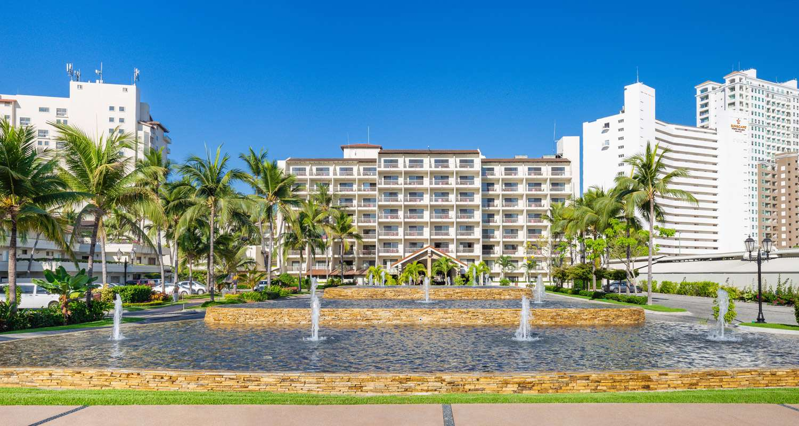

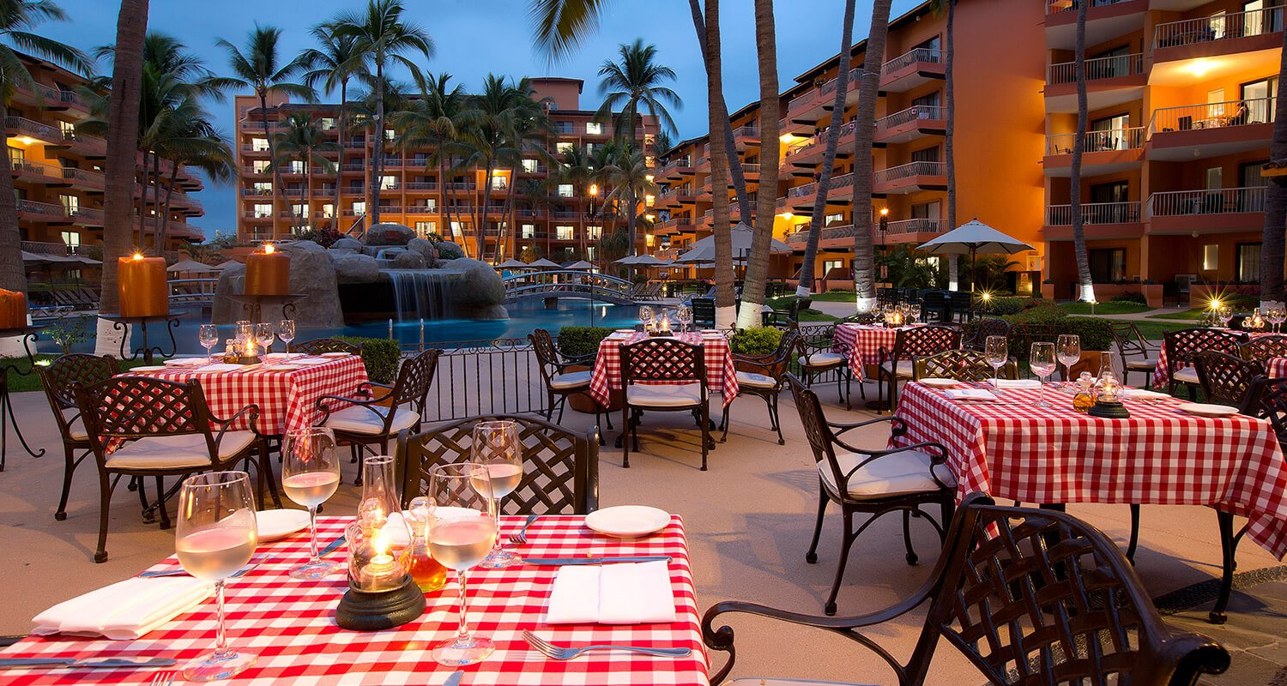

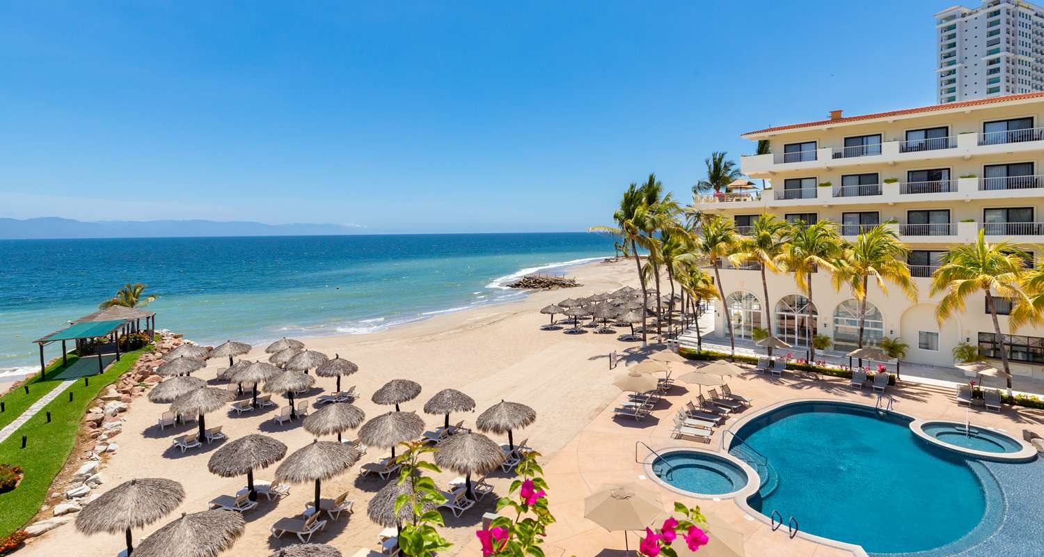

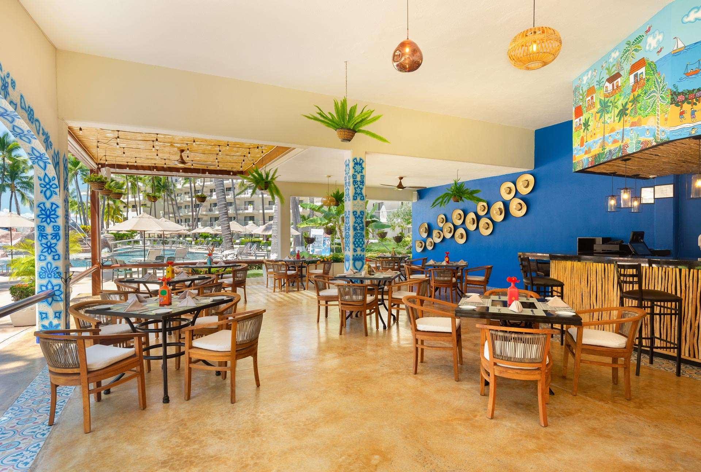

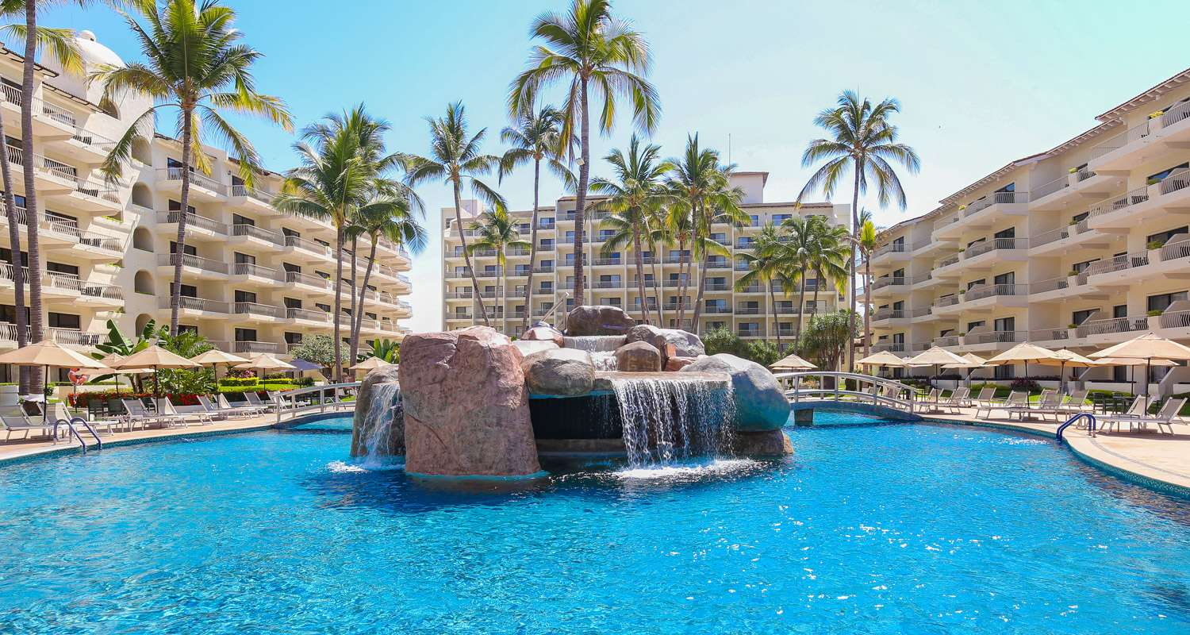

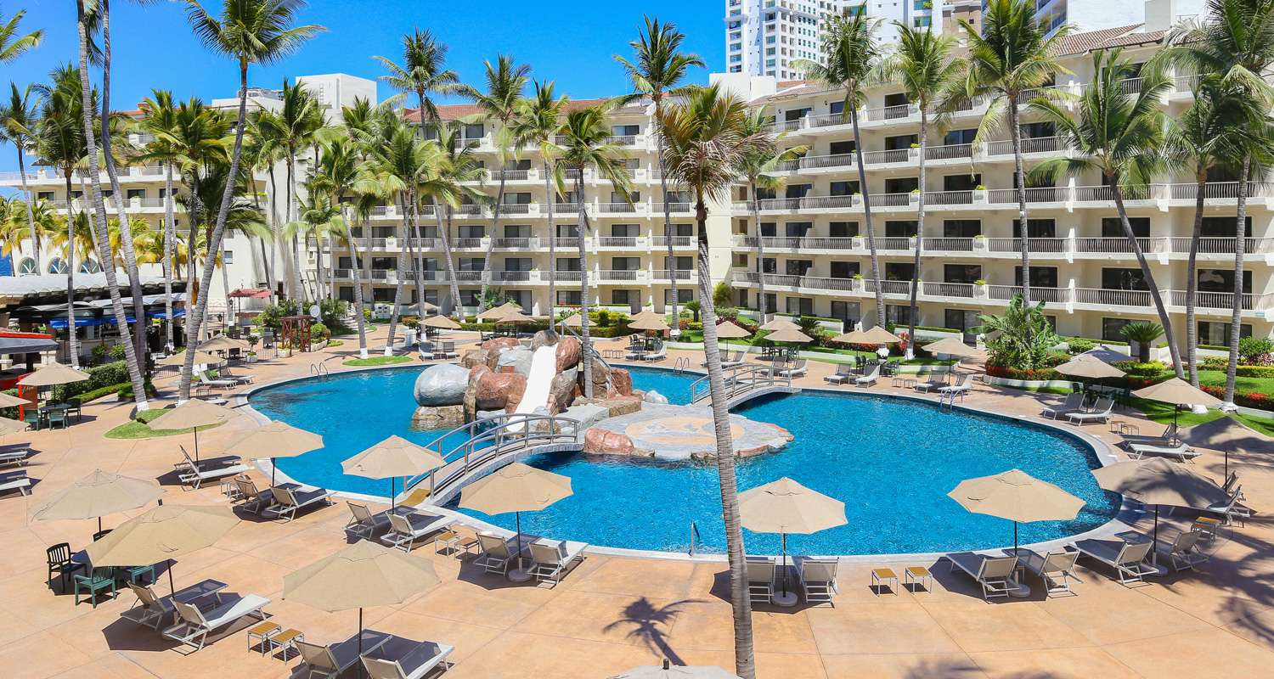

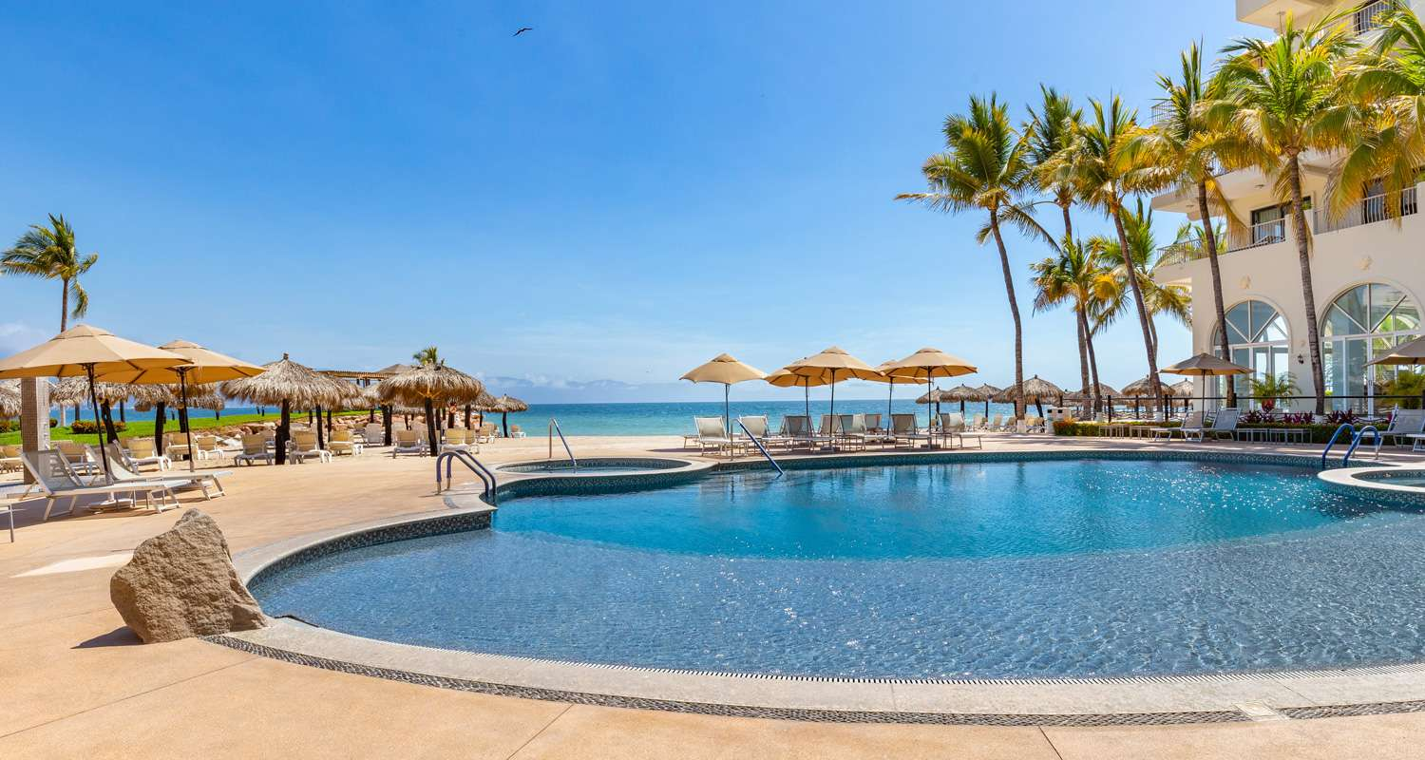

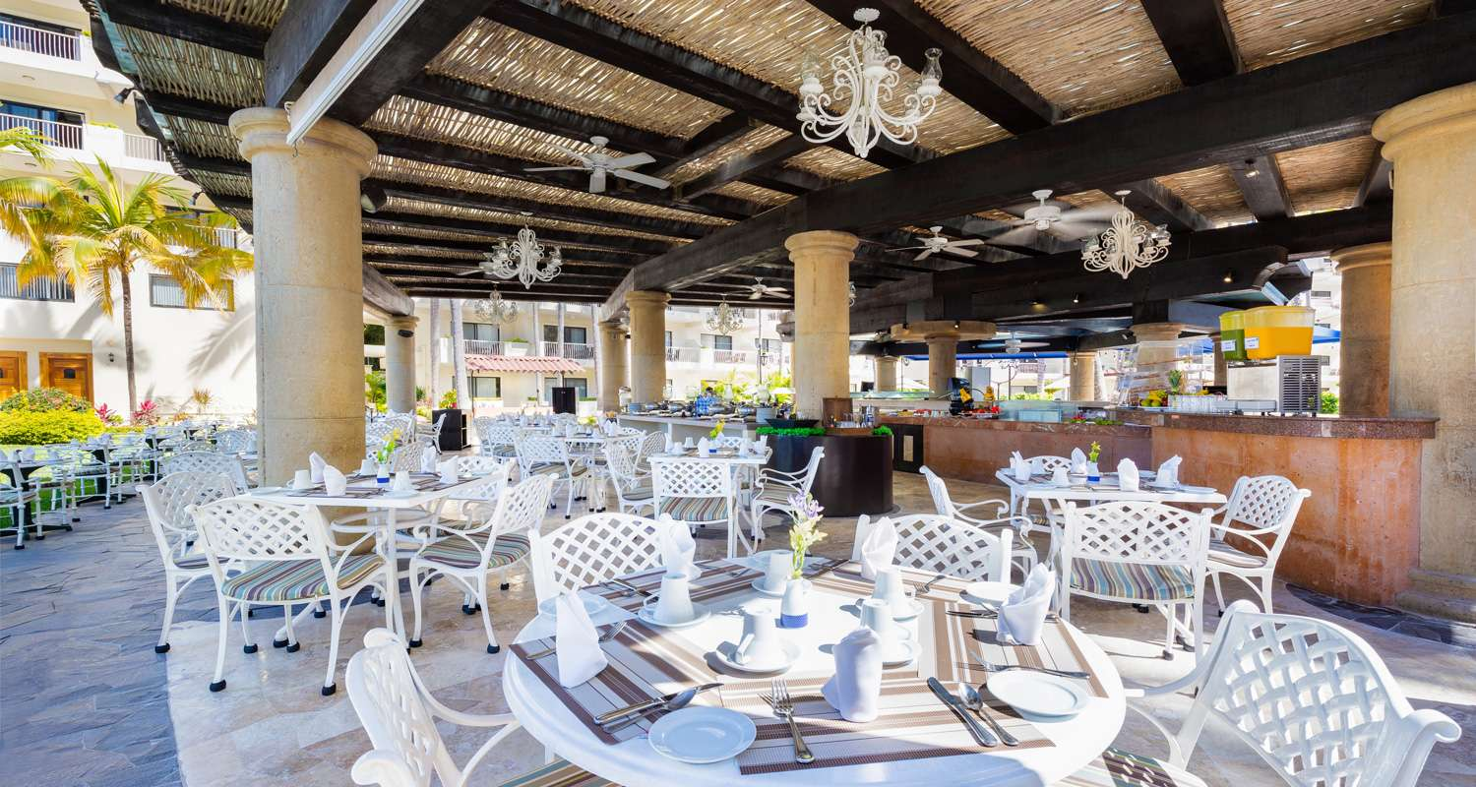

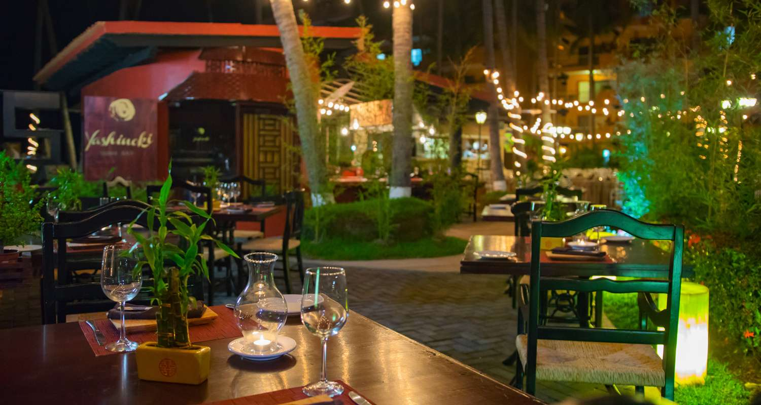

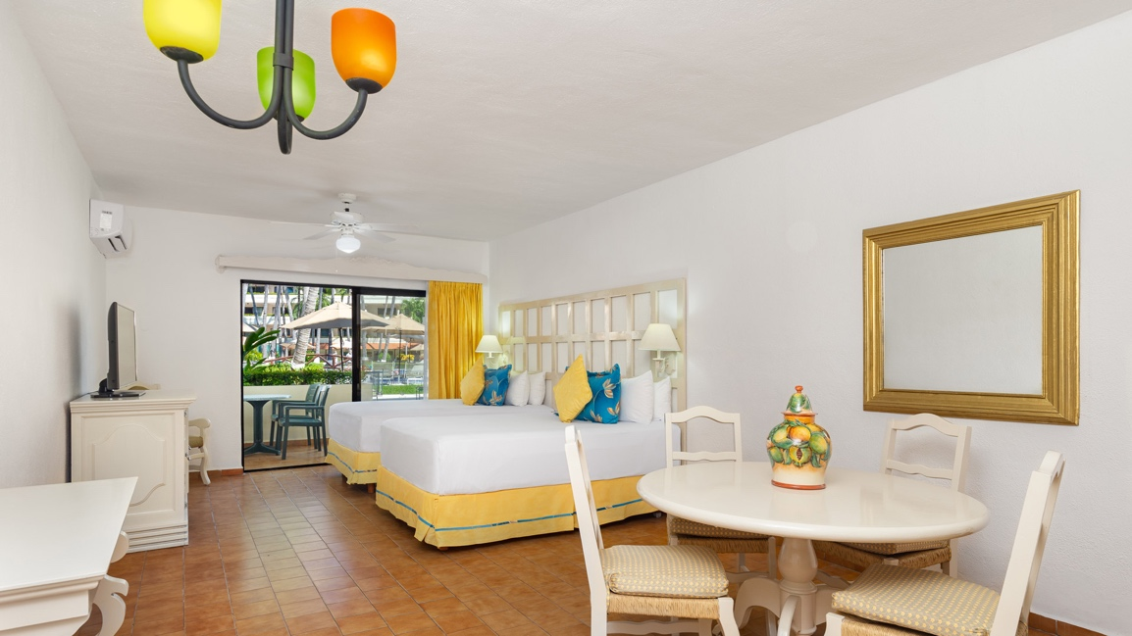

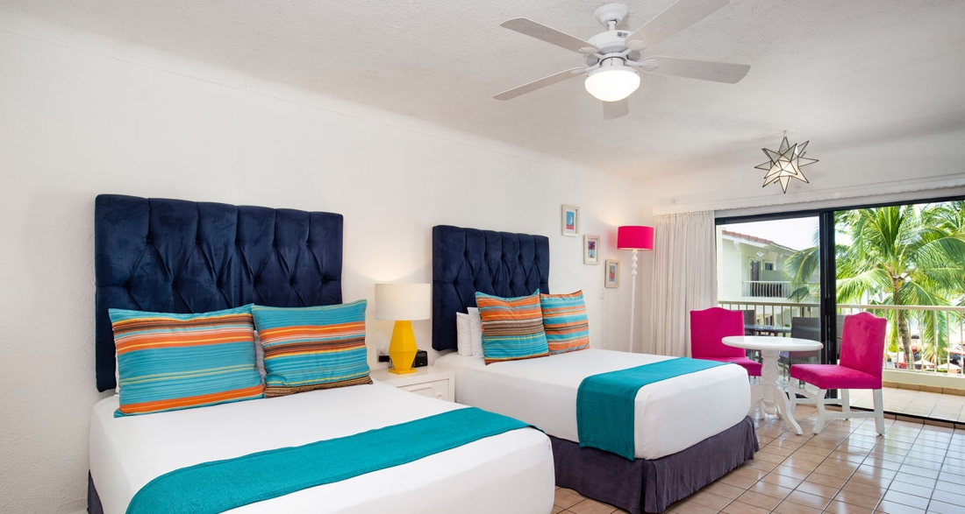

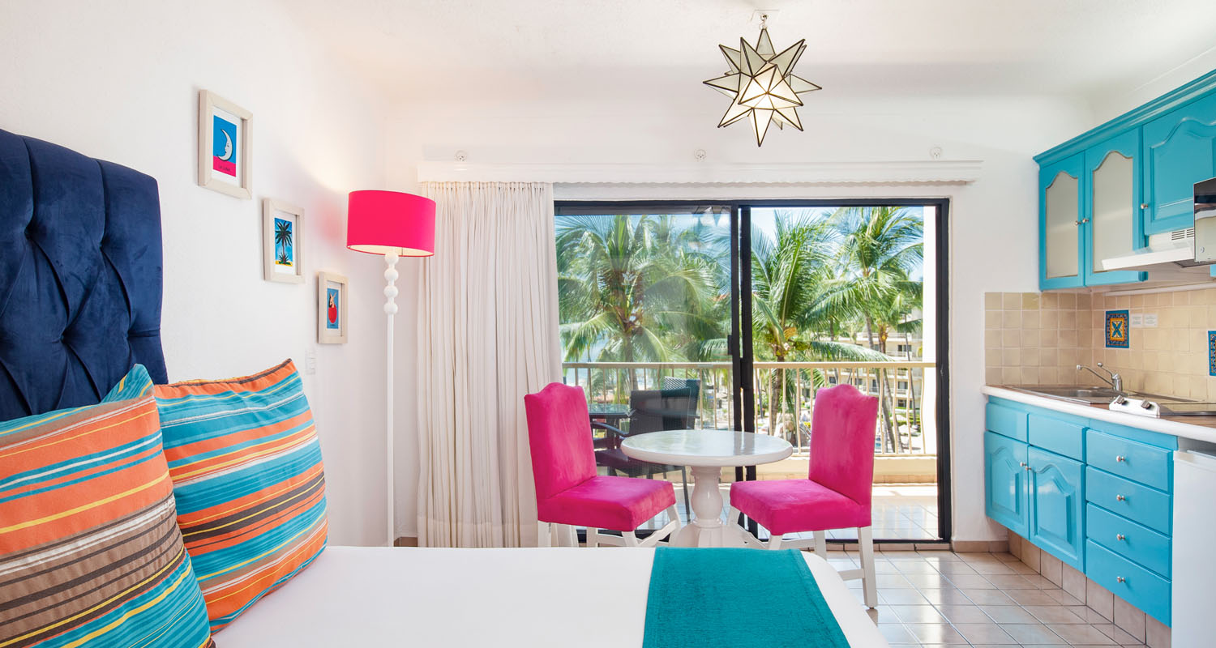

TERMS AND CONDITIONS
- This offer applies for: Married couples, Same Sex couples and Legally single women must be 30 to 70 y.o, Cohabiting couples male client must be 35 to 59 y.o, Single Men clients must be between 35 and 59 years old when attending the Sales Presentation. They must present valid ID’s that include their age, same last name and address as their spouse’s. Otherwise, their children in common (proven) and their ID will serve as proof of marriage for married couples. Their annual combined income must be at least $55,000 USD. Married couples must attend the 90 minutes Sales Presentation together.
- Must have a steady legally recorded job or fully retired.
- Qualified Participants must present at least one (1) valid major credit card such as MasterCard, Visa or American Express at time of the Sales Presentation. Credit cards with any Department Stores Logos (such as Costco, Home Depot, Office Depot, Macy’s, Etc) are not accepted, also Business and Corporate Cards will not be accepted
- Must be US or Canadian residents (not including Quebec, Montreal and Ontario)
- Speak and write fluent English or Spanish and be able to read and sign a legally binding agreement
- Travelers with confirmed reservations who fail to check-in on their reservation date or who fail to reschedule their reservations at least two weeks in advance forfeit voucher – THE NO SHOW PENALTY IS $500 USD AL CHANGES AFTER RECEIVING A CONFIRMATION NUMBER GENERATES A 45 USD CHARGE.
- Exclusive resort orientation provided (explains the resort amenities available) Attending the Sales 90 minutes Presentation (after appropriate scheduling through the concierge of the participating hotel) – IF CONCIERGE FAILS TO CONTACT THE CLIENTS THEY SHOULD GO ON THEIR OWN TO THE SALES PRESENTATION ON THE NEXT DAY OF THEIR ARRIVAL TO THE HOTEL
- Travelers who do not meet these requirements will lose their status of being a Qualified Participant for this package resulting in the Traveler paying the rack rate of the hotel
- Those described bellow will NOT be considered Qualified Participants even if they meet all of the above requirements and will be required to pay the rack rate • Airline, travel agency or hotel industry employees, former time-share employees, Ministers or Pastors and Retired People
• Anyone who has attended the Villas del Palmar Sales Presentation in the past, including Villas del Palmar members
• Participants who have used or will use a similar product before or after their stay at the hotel • Any person whose name is not the original name on the reservation
• If friends and/or family are traveling together with different confirmation numbers, only one of them would qualify for the promotional package and the party who booked second will be required to pay the rack rate.
- Individuals who have traveled to a Resort within the immediately preceding 12 months and attended a Time Share or Vacation Club Presentation
- Individuals who own real estate (including timeshare, fractional or full ownership property interests) in any city in which a Resort is located including Puerto Vallarta, Cabo San Lucas, Cancun and Loreto.
- Individuals who have been invited twice to participate in the promotional package and become qualified Prospects.
- Limit one voucher per household per visit
- Children ages 13 years and up are considered adults and subject to $115.00 USD per adult
- Limit (3) adults per room maximum
- If party exceeds 2 adults and 2 kids or 3 adults and 1 kid, party must pay for additional room, based on occupancy
- Reservations are subject to availability
- Valid credit card and IDs for each guest required at time of check-in.
- Guests are responsible for all applicable government taxes and resort fees, which are collected at point of reservation.
- Clients shall not make arrangements for Tours or Excursions prior to check in.
- Not eligible for room or package upgrades, though may be requested upon registration, subject to resort rate and availability
- No Group Travel - multiple families cannot travel together on this promotion
- Babysitters available, please inquire at resort – WITH ADDITIONAL COST
- Smoking is permitted at resort – IN OPEN AREAS ONLY
- All Coupon buyers are bound to present proof of having attended and completed the Sales Presentation upon their check-out. Failure to present such proof will result in the appropriate loss of his or her quality as Qualified Prospect and will have to pay Rack Rate for the hole stay
- Coupon/Voucher holders, who fail to produce a Reservation Confirmation to the hotel‟s concierge upon their check-in or check-out will be subject to regular fee’s and rates
- Reservation dates must be confirmed 30 days prior to the arrival.
- Airfare is not included with this offer; customers are responsible for their own transportation
- All-inclusive package includes all food, soft drinks, and standard alcoholic beverages
- Room features two Queen beds or 2 double beds
- Resort does provide transportation from airport to Resort.
- Some rooms are handicap accessible, please inquire at booking
- This offer cannot be combined with any other promotion or offer

